

Occasional Paper Series

Improving Water, Sanitation, and Hygiene in Rural Healthcare Facilities in Zambia: Understanding Barriers and Future Policy Directions

Vishal Sundaram
Eunyoo Kim

July 2019

Copyright 2019 Southern African Institute for Policy and Research

Abstract
Inadequate water, sanitation, and hygiene (WASH) are known to pose serious health risks in healthcare facilities (HCFs) in low- and middle-income nations. These issues are of particular concern in Zambia where striking disparities between service provisions in urban and rural areas persist. While existing literature highlights this problem in low-income nations at large, limited information is available on the status of WASH in rural HCFs in Zambia. Through a review of existing literature, stakeholder interviews, and rural facility site visits, this study aimed to better evaluate the current state of water, sanitation, and hygiene in Zambian rural HCFs and to develop health policy recommendations by identifying the barriers to improvement, evaluating the existing standards, and incorporating expert stakeholder feedback.

Findings collectively revealed a need for the improved provision of basic WASH services in rural healthcare facilities in Zambia. While stakeholder feedback provided mixed opinions on the adequacy of existing standards for WASH in HCFs, the absence of implementation, enforcement, and monitoring were of more serious concern. Future policy recommendations were constructed to address a diverse set of identified financial, political, and behavioral barriers to improving WASH in the context of rural HCFs in Zambia.

Acronyms and Abbreviations
WASH – Water, Sanitation, and Hygiene HCF – Healthcare Facility
IPC – Infection Prevention and Control VIP – Ventilated Improved Pit (Latrine) UNICEF – United Nations Children’s Fund WHO – World Health Organization
JMP – WHO/UNICEF Joint Monitoring Program MOH – Ministry of Health
NGO – Non-governmental Organization DHO – District Health Office
SOP – Standard Operating Procedure

Acknowledgements
Centre for Infectious Disease Research in Zambia Cornell University
Lusaka Eye Hospital
Reformed Open Community Schools
Southern African Institute for Policy and Research United Nations Children’s Fund (UNICEF)
  - Centers for Disease Control and Prevention WaterAid Zambia
Zambian Ministry of Health

Introduction
The importance of adequate water, sanitation, and hygiene (WASH) to global health is well- documented. According to a World Health Organization estimate, poor WASH is responsible for nearly one-tenth of the global disease burden and 6.3% of all deaths. These effects, while widespread, are not evenly distributed as the burden of WASH-related disease is disproportionately borne by low-income nations (Prüss-Üstün, Bos, Gore, & Bartram, 2008).
Given the significant contribution of poor WASH to the global burden of disease, it is not surprising that interventions designed to improve WASH have been shown to result in enhanced health, economic, and social outcomes (Bartram & Cairncross, 2010; Fewtrell et al., 2005; Hutton, Haller, & Bartram, 2007).
Healthcare facilities (HCFs) in low-income contexts have become targets for WASH-related research and interventions due in part to the elevated risk of nosocomial (healthcare-acquired) infection posed by poor access to water, sanitation and hygiene (World Health Organization, 2015). These issues are of particular concern in Zambia, where there exists a large disparity between the services provided in rural and urban areas. A survey of more than 200 Zambian rural HCFs found that just over one in five had access to improved water sources on premises, improved sanitation, and consistent access to water and soap for handwashing (Amy Guo, Michael Bowling, Bartram, & Kayser, 2017). Given the potentially far-reaching consequences of this finding and the relatively limited availability of published literature regarding WASH in Zambian rural HCFs, further investigation is required.
This study used a qualitative approach to 1) observe and better describe the state of WASH in rural HCFs in Zambia, 2) evaluate the existing Zambian national standards relative to global standards for WASH in HCFs, 3) assess rural facility compliance with these standards, 4) identify and understand the barriers to improving WASH in rural HCFs, and 5) make policy recommendations.

Methods

Review of Existing Literature
Literature searches were used to consolidate information related to the status of WASH and its importance to public health in rural HCFs. To supplement information exclusive to Zambia, we broadened our scope to include the same subject in other low- and middle-income countries. Our search criteria included journal articles and reports published since 2000 (accessible via PubMed or Google scholar), Zambian budget reports from 2018 and 2019, and national and global statistical reports on the availability of WASH-related services in HCFs. Another set of searches focused on both qualitative and quantitative studies of past strategies and interventions for improving WASH practices in HCFs. These findings were used to inform recommendations for future policy.

We additionally sought to create an inventory of existing standards and policies governing WASH in healthcare facilities at both the national and global level. The international standards for WASH in HCFs published by the UNICEF/WHO Joint Monitoring Programme were directly compared with the Zambian Minimum Standards jointly developed by the United Nations, the

European Union, and the Zambian Ministry of Health with the goal of highlighting any significant discrepancies.

Expert Stakeholder Interviews and Site Visits
We recruited a professionally diverse panel of expert stakeholders for interviews. Stakeholders came from a variety of backgrounds and levels of influence, including rural health posts, international non-profit organizations, and the Zambian Ministry of Health. Interview questions were tailored to the expertise of each stakeholder to gain comprehensive and targeted feedback on the state of WASH in rural healthcare facilities, existing standards on WASH, and barriers to improving WASH in rural HCFs.

Primary accounts of WASH in rural HCFs were collected from site visits to Njola Mwanza Clinic and Chipembele Health Post located in the Monze district of Southern Province. The state of WASH in each health facility was evaluated by conducting interviews with the healthcare personnel and visually surveying the facilities using the JMP sample core questions adapted for Health Management Information Systems (HMIS).

Background and Review of Literature
It has been estimated that at least 9.1% of the total global burden of disease and 6.3% of all deaths could be prevented solely by improving access to adequate water, sanitation, and hygiene. Common intermediaries for this pronounced burden include such conditions as diarrheal diseases, malaria, malnutrition, and lymphatic filariasis (Prüss-Üstün et al., 2008). Though widespread and consequential, the adverse health outcomes resulting from poor WASH are by no means uniform in their global distribution as this burden is disproportionately borne by those in low- and middle-income countries. It has been reported that the burden of WASH- related illness in developing countries is more than ten times that found in developed countries (Prüss-Üstün et al., 2008). In the same vein, nearly three-fourths of all diarrheal mortality – a leading contributor to WASH-related disease burden – is concentrated in only 15 developing countries (Bartram & Cairncross, 2010). Among the reasons for the elevated risk of WASH- related illness in these contexts are the infrequency of hand hygiene practices, the unavailability of adequate sanitation facilities, and the use of unsafe water supplies (Pruss- Ustun et al., 2014).
Considering the strong link thus established between inadequate WASH and the global disease burden, it immediately follows that interventions designed to improve WASH can improve health outcomes. A meta-analysis of interventions designed to reduce illness in less developed countries through improvements in drinking water, hygiene practices, and sanitation facilities found reductions in diarrheal disease risk ranging from 25% to 37% (Fewtrell et al., 2005).
Furthermore, the benefits of these interventions extend beyond health. WASH-associated mortality and morbidity come with social and economic costs stemming from such sources as stunting, impaired cognitive function, healthcare expenditures, and reduced school and workplace productivity (Bartram & Cairncross, 2010; Prüss-Üstün et al., 2008). Due to these

indirect consequences, it has been demonstrated that a 1 USD investment in WASH improvements can yield a return in the range of 5 – 46 USD (Hutton et al., 2007).
Healthcare facilities in developing countries have become a global focus for potential WASH interventions due to the health risks posed by inadequate access to water, sanitation, and hygiene services in these contexts. An analysis of over 60,000 HCFs in 54 low- and middle- income countries found that more than one-third lacked access to either an improved water source or soap for handwashing, while 19% did not have improved sanitation facilities according to guidelines put forth by the WHO/UNICEF Joint Monitoring Programme. Disparities in WASH provisions presented themselves even within these countries, with rural facilities having disproportionately fewer WASH services than their urban counterparts (Cronk & Bartram, 2018; World Health Organization, 2015).
These findings are concerning because of their implications for the occurrence of healthcare- acquired (nosocomial) infections. A meta-analysis found the prevalence of nosocomial infection in resource-limited settings to be three times that found in the United States and more than double that found in Europe (Allegranzi et al., 2011). While a study of the endemic burden of healthcare-acquired infection in Africa found limited information, the available data were sufficient to reveal a much higher risk of nosocomial infection than that found in high-income countries (Nejad, Allegranzi, Syed, Ellisc, & Pittetd, 2011). Given that improved hand hygiene compliance alone has been shown to result in large reductions in the rate of healthcare- acquired infection (Cronk & Bartram, 2018; Kampf, Löffler, & Gastmeier, 2009), deficiencies in WASH provisions likely have a large role to play in the elevated nosocomial risk in low-income contexts. Another less studied but perhaps significant health consequence of poor WASH in HCFs is the possibility of deterring patients from seeking medical care in the first place (Huttinger et al., 2017).
Though the availability of information regarding the status of WASH in rural HCFs in Zambia is limited, one available study found that just 21% of over 200 rural facilities surveyed had access to improved water sources on premises, improved, sanitation, and consistent access to water and soap for handwashing per WHO/UNICEF standards (Amy Guo et al., 2017). These findings were generally corroborated by the 2016 Zambian country data collected as a part of the WHO/UNICEF Joint Monitoring Programme, which found just 50.9% of rural HCFs to have access to a basic water source and 0% to have access to basic sanitation, compared to the respective metrics of 58.4% and 100% for these same designations in urban areas (“WHO/UNICEF JMP Zambia Country Profile: WASH services in health care facilities,” 2016). The disparity between rural and urban facilities is further illustrated by the status of toilets in each context: while 76% of rural facilities reported using some form of latrine, 89% of urban facilities had flush toilets (Republic of Zambia Ministry of Health, 2010).

Obstacles to Improving WASH in Zambian Rural HCFs
Examination of existing literature reveals that financial constraints are partially responsible for the inadequate state of WASH in Zambian rural HCFs given that many solutions are expensive and currently impractical in low-income communities (Mara, Lane, Scott, & Trouba, 2010).
While government health sector spending as measured by real per capita allocation has been on the rise since 2016, its share of the total budget fell from 9.5% in 2018 to 9.3% in 2019.

According to third party budget analyses, this allocation for the National Health Budget is insufficient to address Zambia’s current health sector challenges and falls short of the Abuja Declaration target of 15% set by the African Union nations in 2001 (UNICEF and Zambia Institute for Policy Analysis & Research, 2017, 2018). Dependence on external donor support for 60% of all health expenditures raises additional concerns regarding the long-term sustainability of current health sector funding strategies. Given that donor funds are generally earmarked for specific purposes, they cannot easily be used by the government to strategically fund its long-term priorities (UNICEF and Zambia Institute for Policy Analysis & Research, 2017). Insufficiency and inflexibility of funding for health thus present a combined obstacle to improving WASH.
Though the Zambian government’s budget for water and sanitation roughly tripled in 2019 largely in response to a 2018 cholera outbreak in Lusaka, rural areas have gained little from these efforts (UNICEF and Zambia Institute for Policy Analysis & Research, 2018). For the past two years, there has been a prioritization of water infrastructure development in urban and peri-urban areas with 43% of all water and sanitation funding in 2018 going to projects in Lusaka alone (UNICEF and Zambia Institute for Policy Analysis & Research, 2017). While the Finance Minister’s 2019 Budget Speech uses the urban prevalence of water-borne diseases to justify this bias in the allocation of financial resources (Mwanakatwe, 2018), a focus on urban demands could harm rural health and exacerbate already existing disparities between rural and urban Zambia. This outcome would run counter to goals for equitable development outlined in the 7th National Development Plan (Ministry of National Development Planning, 2017; UNICEF and Zambia Institute for Policy Analysis & Research, 2017).
Human resource deficits compound these financial obstacles to improving WASH in rural HCFs. As of 2017, Zambia had filled just two-thirds of its required healthcare worker positions, while government plans to create new facilities are projected to generate even more demand (UNICEF and Zambia Institute for Policy Analysis & Research, 2017). This already pressing shortage of healthcare personnel in Zambia is felt hardest in rural areas due to a bias in the distribution of workers toward the more prosperous and developed urban areas (Herbst, Vledder, Campbell, Sjöblom, & Soucat, 2011). High patient load relative to the number of available facility staff in rural contexts can create a sense of urgency to see patients at the expense of following proper hand hygiene procedures and infection prevention protocols (Chipungu et al., 2018). Indeed, a common reason cited for low hand hygiene compliance in facilities from a wide range of global contexts is a lack of time (Lankford et al., 2003; Mathai, George, & Abraham, 2011; Mearkle, Houghton, Bwonya, & Lindfield, 2011).These findings suggest that WASH-related disease burden in rural HCFs may be linked to an inadequate supply of human resources.
The available literature suggests a final set of behavioral barriers to improving WASH in rural HCFs. An observational study conducted in four peri-urban Zambian HCFs found that soap was used in only 1% of all handwashing behaviors observed among healthcare workers (Chipungu et al., 2018). While the absence of soap or limited availability of functional sinks may have been partly to blame, behavioral norms and insufficient training and awareness among healthcare personnel have also been shown to play a role. For instance, it has been reported that

forgetfulness and overconfidence in one’s ability to predict disease transmission may contribute to low staff hand hygiene compliance (Mearkle et al., 2011). These harmful behavioral norms are perpetuated by incomplete awareness among healthcare workers of the risk of hospital-acquired infection and exclusion of infection prevention protocols and guidelines from training curricula (Mukwato, Ngoma, & Maimbolwa, 2011).

Strategies and Interventions
Hardware
Several studies have demonstrated the health benefits of improving WASH-related infrastructure in HCFs. A project in 150 rural Zambian facilities illustrated the effectiveness of inexpensive WASH improvements such as installing water containers with taps and soap at strategic points. Such interventions increased handwashing frequency, raised satisfaction with health services, and even improved household hygiene practices (Stephenson et al., 2006; World Health Organization, 2015). While efforts to improve sanitation hardware have been shown to markedly reduce diarrheal illness, water treatment efforts show small long-term effectiveness and falling compliance rates (Waddington & Snilstveit, 2009). These findings suggest a need for software interventions, such as improved education, training, and awareness, to work alongside hardware solutions.
Software
A considerable number of behavior-change studies have found that emotional drivers are effective mechanisms for improving compliance with WASH protocols (Bartram & Cairncross, 2010; Biran et al., 2014). As the fear of infection among healthcare workers serves as a strong motivator for handwashing (Chipungu et al., 2018), compliance has been shown to improve when staff perceive the personal health hazard associated with nosocomial infection (Lankford et al., 2003). Such emotionally driven behavior change can be initiated through heightened risk awareness and improved training. Indeed, it has been demonstrated that strong adherence to infection prevention protocols among healthcare workers is associated with the inclusion of IPC guidelines in staff training, knowledge of hospital acquired infection, and positive attitudes toward IPC (Mukwato et al., 2011). Effective behavior change strategies involve a multifaceted approach, incorporating some combination of education, training, written materials, visual aids, and continuous performance feedback (Mathai et al., 2011; Naikoba & Hayward, 2001).
Policy
While the previously outlined strategies have theoretical scope, they are not viable without institutional support. A comprehensive national monitoring system for WASH in HCFs and a clear set of standards and guidelines are necessary to ensure facility accountability (Cronk, Slaymaker, & Bartram, 2015). These must be supported by establishing clear political leadership, institutional responsibility, and specific budget lines for WASH (Mara et al., 2010).

Existing Standards
Global
The current international guidelines used for the monitoring of the status of WASH in HCFs are the core indicators created by the WHO/UNICEF Joint Monitoring Programme (JMP) for Water Supply, Sanitation, and Hygiene. These standards outline a detailed set of criteria and definitions used to classify facilities as having either basic, limited, or no service in the five key areas of water, sanitation, hygiene, health care waste management, and environmental cleaning. These classification schemes, termed “service ladders”, are used to create a standardized system by which to classify and compare healthcare facilities around the world (see Figure 1).
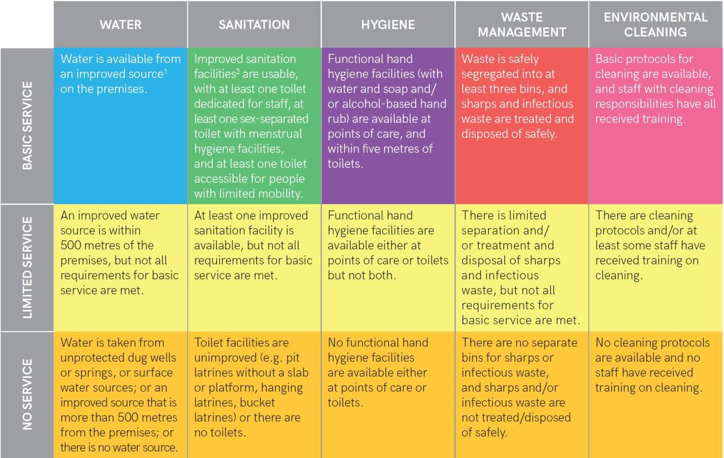
Figure 1. JMP service ladders for monitoring basic WASH services in healthcare facilities (Source: Core questions and indicators for monitoring WASH in health care facilities in the Sustainable Development Goals. UNICEF & WHO, 2016)

Domestic
While no official Zambian national standards for WASH in HCFs are publicly available, a document jointly developed by the Zambian Ministry of Health and the United Nations entitled “Infection Prevention and Control Water Sanitation and Hygiene in Health Care Facilities: The Minimum Standards”(Republic of Zambia Ministry of Health, 2017) was obtained from a contact at WaterAid Zambia. This document proposes a set of baseline requirements for healthcare facilities, detailing standards and guidelines for water, sanitation, hygiene, solid waste management, cleaning, and infection prevention and control.

Findings

Site Visits
Site visits to two WaterAid-partnered rural HCFs in Monze district yielded primary accounts on the state of WASH and staff awareness of WASH practices. The observational findings were guided by the JMP sample core questions for health care facilities and supplemented by our own photographs and notes from staff interviews. Detailed notes and additional photographs can be found in Appendix B and C.

Njola Mwanza Clinic
Observational Findings
The main water source for this facility was a borehole with an electric pump connected to a 5000-liter elevated tank. While no running water was available within the building, a water collection point was located on facility grounds within 500 meters of the building. The water supply was continuous at the time of our visit, but staff noted that it may not be continuous during the dry season. For patients, there were two sex-separated VIP latrines with slabs lacking accommodations for menstrual hygiene and patients with limited mobility. Staff reportedly used toilets in nearby staff housing off-premises. While hand washing facilities were absent at primary points of care and near the toilets, a communal hand washing bucket with tap and soap was located immediately outside of the consultation room. Infectious waste and domestic waste were labelled and separated into two color-coded plastic bags and leak-proof bins with lids inside the consultation room while a sharps container was absent. A single-chambered incinerator was found on facility grounds. These observational findings were used to assess this clinic using the JMP WASH service ladders (see Table 1).

Table 1. Assessment of Njola Mwanza Clinic Using JMP Service Ladders
 | Service Ladder Classification | Rationale
Water | Basic | Water continuously sourced from a borehole on facility grounds
Sanitation | Limited | Lack of menstrual hygiene facilities and accommodations for patients with limited mobility
Hygiene | No service | Handwashing unavailable in consultation room and near toilets
Waste Management | Limited | Lack of sharps container in consultation room
Environmental Cleaning | Limited | Cleaning protocols unavailable and insufficient staff training on cleaning

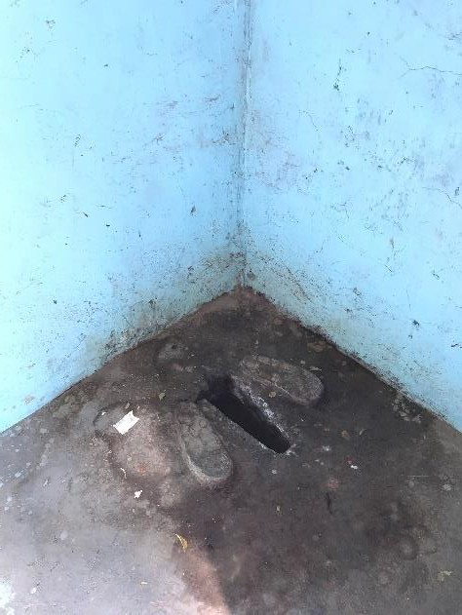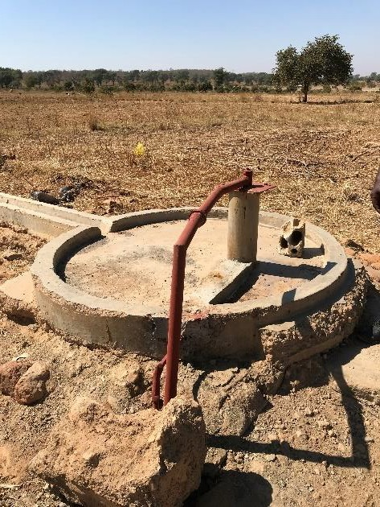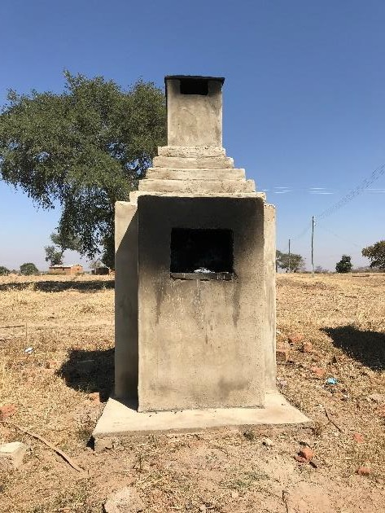
    - (b) (c)

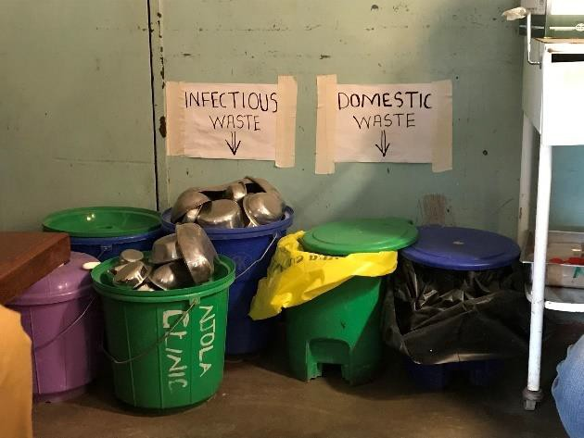
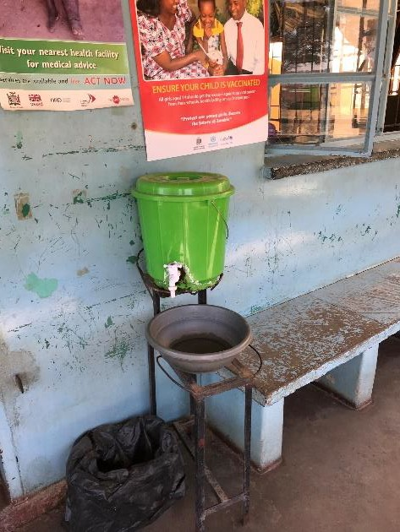
Figure 2. WASH at Njola Mwanza Clinic. (a) VIP latrine with slab; (b) borehole with electric pump; (c) waste incinerator; (d) handwashing bucket with tap outside consultation room; (e) infectious and domestic waste bins in consultation room

(e)

(d)

WaterAid Zambia is currently intervening at this facility to build a new borehole near the facility and a piped scheme that connects the water source to the building. The construction will contain flushable toilets and showers within the maternity annex and hand washing facilities within the buildings.

Interview Findings
The clinical officer in charge of this facility, Mr. Goodwin Namakungwa, reported a lack of running water within the facility and an insufficient number of toilets for the patients and staff. Due to the heavy workload and urgency resulting from understaffing, hand washing by staff is not always practiced. While waste management protocol was present, he reported that the available incinerator was below standard and that cleaning protocols were absent. An ash pit

and toilet pit were used for the disposal of incinerated waste. He reported an awareness of the existence of standards for WASH in HCFs but was unaware of the source. However, he affirmed that these standards would be achievable with additional hardware support. This clinic performs infection prevention and control through provision of community health education regarding WASH, submission of quarterly reports on community environmental health, and submission of monthly surveillance reports to the Monze district hospital. While Mr.
Namakungwa detailed the facility’s outbreak response protocol and mentioned the use of antiseptic for cleaning, there was no specific training on IPC guidelines or environmental cleaning available for staff. He maintained that hospital-acquired infections were not common in this facility. Over the course of the interview, he noted several barriers to improving WASH in the facility such as insufficient funding, understaffing, and the deterioration of existing water infrastructure. Suggested improvements included enhanced health education and community engagement.

Chipembele Health Post
Observational Findings
The main water source for this facility was a hand-pumped borehole positioned on facility grounds located within 500 meters of the building. The water supply was reported to be continuous throughout the year. There was no running water within the facility. There were two sex-separated VIP latrines with slabs for patients and one staff toilet that was under construction. Accommodations for menstrual hygiene and patients with limited mobility were absent in the toilets. Hand washing facilities were absent both in the consultation area and near the toilets. One hand washing bucket with tap and soap was available outside of the facility and was shared by all staff and visitors. There were no waste disposal bins in the consultation room. Inside the examination room, the general waste and infectious waste were separately disposed into two leak-proof bins with lids and a sharps box was present. All wastes were burned in a common unlined, unprotected pit on the perimeter of the facility grounds. These observational findings were used to assess this health post using the JMP WASH service ladders (see Table 2).

Table 2. Assessment of Chipembele Health Post Using JMP Service Ladders

 | Service Ladder Classification | Rationale
Water | Basic | Water continuously sourced from borehole on facility grounds
Sanitation | Limited | Lack of menstrual hygiene facilities and accommodation for patients with limited mobility
Hygiene | No service | Handwashing unavailable at points of care and near toilets
Waste Management | Limited | Open burning of waste in an unlined, unprotected pit; lack of waste disposal bins at points of care
Environmental Cleaning | Limited | Cleaning protocols unavailable and insufficient staff training on cleaning

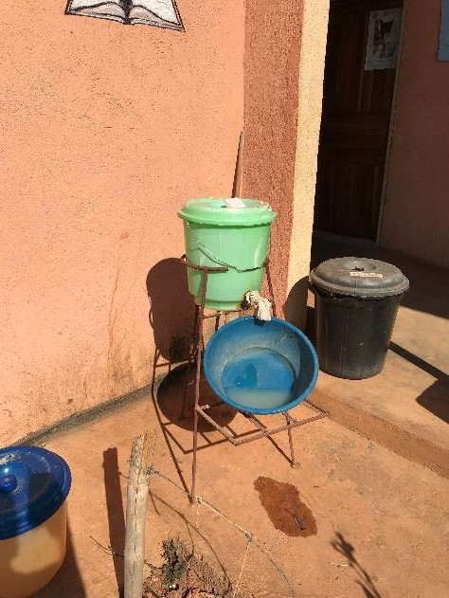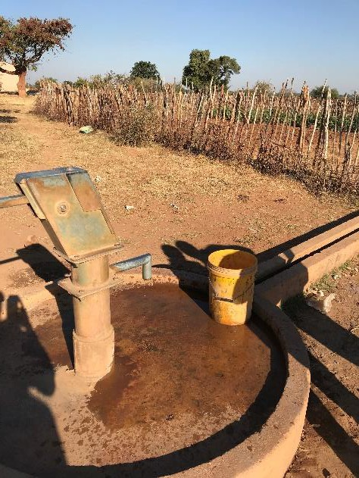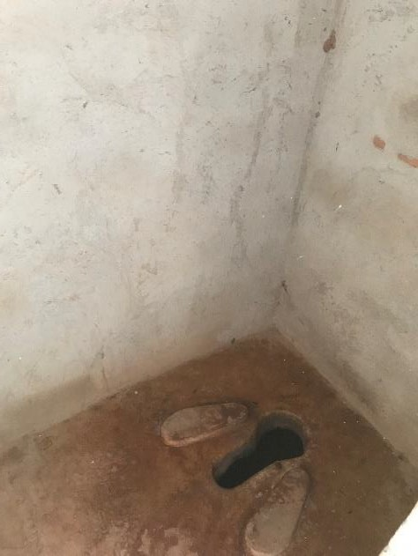

      - (b)
(c)

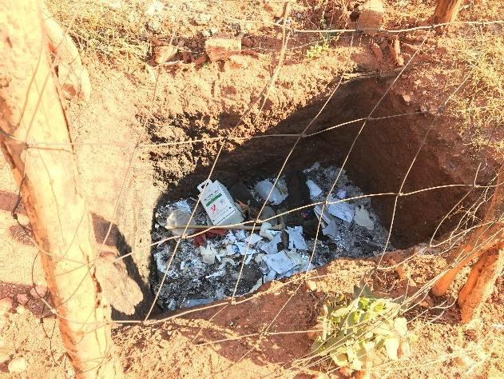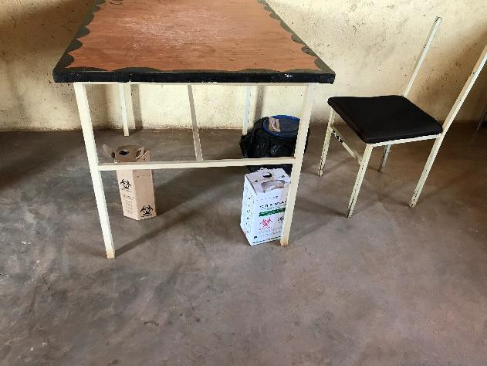
(d) (e)
Figure 3. WASH at Chipembele Health Post. (a) handwashing bucket with tap and soap outside facility;
      - borehole with hand pump; (c) VIP latrine; (d) unprotected pit for burning waste ; (e) waste bins outside of consultation room

WaterAid Zambia is currently intervening at this facility to place an elevated water tank with the already constructed borehole. The water source will be connected to the building via piped scheme that supplies water into the future maternity annex and flushable toilets for patients and staff currently under construction.

Interview Findings
The nurse in charge of this facility, Mr. Alex Mwiinga, reported a lack of running water, an insufficient number of hand washing buckets and toilets, and a lack of incinerators for the treatment of waste. Cleaning protocols and schedules were not available at the facility. He demonstrated an awareness of the existence of standards for WASH and IPC, but reported that he had not been explicitly provided with any guidelines. The community health workers at this

facility provide education on WASH and health in the community. The nurse resides in staff housing near the facility and utilizes patient visits as an opportunity to provide health education. Though the frequency of inspection is irregular, the clinic submits performance assessments twice a year. The facility has an outbreak response protocol, but it was not derived from a standard IPC guideline and the staff reported difficulty with community compliance with safe WASH practices. The facility bears the responsibility of distributing DHO-provided chlorine to the community for the disinfection of water. Mr. Mwiinga provided anecdotal evidence of a correlation between the depletion of these chlorine supplies and an increased incidence of diarrheal illnesses (despite the fact that community members are instructed to boil water in such times). While there was no specific training on IPC or environmental cleaning that the staff present had received, the facility is occasionally visited by an environmental health technician from a nearby health facility who was believed by the staff to be more familiar with such guidelines. He reported his unawareness of hospital-acquired infection but showed an understanding that it may be an issue at a healthcare facility. He noted several barriers to improving WASH in the facility, including understaffing, an insufficient number of WASH facilities, inadequate funding, and low risk awareness in the community. Among his suggestions for future improvements were the use of posters and visual aids for WASH and the construction of an incinerator for proper waste treatment and disposal.

Other Stakeholder Interviews

Lusaka Eye Hospital
A cataract surgeon and outreach coordinator from Lusaka Eye Hospital, Dr. Moonga Argent, provided his accounts of WASH in rural HCFs from ten years ago. In the past, the most common water source in the rural HCFs he visited was a central borehole that was off-premises and shared with the community. An absence of running water inside the facility building was commonplace. He noted that government-funded boreholes have since been installed to provide facilities with a water supply that is on-premises. Several other improvements made in recent years were attributed primarily to NGO-led interventions. Though the occurrence of infections such as trachoma was reported to be common in rural areas and rare in urban areas, he conceded that it was difficult to quantify the extent to which such infections were attributable to poor WASH in the healthcare environment. The existing guidelines for WASH in HCFs were believed to be sufficient and feasible even in rural contexts. Though he was confident that facilities are trying to meet these standards, they presently struggle to do so because they lack the required resources. Dr. Argent noted several barriers to improving WASH in rural HCFs such as inadequate funding, poor maintenance of facility WASH infrastructure, and low levels of community mobilization to improve institutional WASH. It was suggested that NGOs with external funding continue to play a critical role as cooperating partners by initiating WASH interventions and encouraging the government to scale them up.

An Anonymous American Non-profit Organization

Two officials from this organization reported their observations on WASH in rural HCFs. To their knowledge, most of these facilities used boreholes and lacked piped running water inside the

building. Pit latrines were the most common form of sanitation and sewage networks were missing in the facilities. Though the national standards for WASH in HCFs were believed to be aligned with the JMP guidelines, enforcement mechanisms and MOH support were said to be required for facilities to meet these standards. Waste disposal and water supply were the areas appearing to require greatest improvement. Despite the presence of a robust health surveillance system throughout the country, there has been little investigation on WASH- related diseases and hospital-acquired infections in rural HCFs. Therefore, the public health surveillance system must include indicators for the detection of such illnesses. The main barriers to improving WASH in rural HCFs that were raised included limited funding allocated for WASH infrastructure, shortages of staff trained in WASH principles, the deprioritization of WASH on policy agendas, and the disconnect between the ministries with overlapping responsibilities. The suggested solutions to the Ministry of Health were to take greater responsibility for the enforcement of standards, to make WASH in HCFs a policy priority, and to establish a more honest conversation with other aligned ministries such as the Ministry of Water Development, Sanitation, and Environmental Protection.

UNICEF
A UNICEF official described the organization’s extensive partnership with Ministry of Health for the purposes of knowledge generation, advocacy, and policy strategization. The organization has played an advisory role for the Ministry in publishing standard operating procedures (SOPs) for WASH in HCFs, an IPC training manual, and the Minimum Standards for WASH in HCFs. The organization has focused on urban areas due to the Ministry’s prioritization of centers with greater population and demand. As a result, recent projects were launched in Lusaka and Copperbelt districts. Though the official was confident that the MOH Minimum Standards published with the guidance and assistance of UNICEF have been designed in accordance with the WHO/UNICEF JMP guidelines, it was admitted that permanent change and enforcement of these standards were the responsibilities of the Ministry of Health. The Public Health Act of Zambia, while currently under review, will eventually contain elements that allow the government to enforce WASH standards in HCFs. The main barriers mentioned to improving WASH in rural HCFs included poor maintenance of facility infrastructure, the limited capacity of local available human resources, and insufficient financial resources for long-term operation of facilities. An emphasis was made on moving away from the traditional means of resource mobilization in favor of more innovative funding strategies capitalizing on business incentives and investment from the private sector. In addition, the vulnerability of many current water and sanitation solutions to changing rainfall patterns may allow NGOs and the government to tap into climate change-related funds for WASH. The importance of further research and advocacy on the importance of WASH in HCFs was highlighted help to reinforce knowledge generation in the population and shift political priorities.

Ministry of Health

The Chief Environmental Health Officer, Mrs. Florence Mwale, reported that most of the rural HCFs in Zambia lack running water and safe water sources. The facilities are likely to have inadequate sanitation facilities, absence of staff toilets and an insufficient number of toilets for

patients with special needs. The rural HCFs lack hardware for maintaining hand hygiene and decontaminating the clinical environment. Such problems with WASH in a health care environment elevate the risk of nosocomial infection to other patients and staff, set a poor example for the community, and pose environmental hazards. She believed the current Minimum Standards to be inadequate compared to the JMP standards and revealed that the published standards constitute a proposal rather than an official Ministry-approved policy. The Ministry of Health, therefore, is planning to legally integrate and institutionalize WASH components in a revised version of the Public Health Act. Mrs. Mwale noted several barriers to improving WASH in rural HCFs, including the deprioritization of WASH in facility planning and funding, urban biases in budgetary and human resource allocation, a lack of awareness of the occupational risk and public health hazards associated with poor WASH, and the exclusion of environmental safeguards and WASH components from global funding mechanisms.
Suggestions for improvement included advocating for WASH to receive its own funding at the global level, creating a separate national budget line for WASH in HCFs of all levels, domesticating the JMP indicators into the national performance assessment system to monitor WASH in HCFs, publishing the stories of successful HCFs to serve as role models for others, and developing detailed technical standards for constructing WASH infrastructure.

Detailed notes on each of the stakeholders’ opinions on specific barriers to improving WASH
are organized into five different categories and can be found in Appendix C.

Evaluation of Standards
The extent to which the MOH Minimum Standards aligned with the international standards differed in each of the five service ladder categories. The alignments and discrepancies from comparing the Ministry of Health Minimum WASH Standards (Republic of Zambia Ministry of Health, 2017) and the JMP Core Questions for Monitoring WASH in HCF (United Nations Children’s Fund & World Health Organization, 2016)are organized in Table 3. Any critical definitions that were present in the JMP document but absent in the MOH document were noted.

 | JMP Components Present in MOH Standards | JMP Components Absent in MOH Standards
Water | Adequate, improved water sources include protected groundwater source (spring, well, or borehole) or a treated water (piped, packaged or delivered water) that is safely stored until usage.  Water supply is continuously available. | Unimproved sources include unprotected dug wells or springs and surface water (e.g. lake, river, stream, pond, canals, irrigation ditches).  Water source should be located on premises, accessed within buildings or within the facility grounds.
Sanitation | Sanitation facility should be sex-separated with menstrual hygiene facilities and should provide for people with disabilities.  Toilets should be separated for patients and staff. | N/A
Hygiene | Hand hygiene facilities such as fixed sink or portable devices are available with water and soap, or hand sanitizers.  Hand washing facilities are available in at least one or more point of care and near toilets. | Alcohol-based rub is not considered adequate for hand hygiene at toilet as it does not remove fecal matter from hands.  Chlorinated water is not considered an adequate substitute for soap and water or for alcohol-based hand rub.
Waste Management | Waste is safely segregated at the point of generation (areas where care or treatment is delivered).  Hazardous waste is incinerated. It also may be collected and transported off-site for medical waste treatment and disposal. | At least three clearly labeled bins should be available for (1) sharps waste, (2) infectious waste, and (3) non-infectious general waste.  The bins for sharps waste and infectious wastes should have lids.  Safe treatment and disposal methods include incineration, autoclaving, and burial in a lined, protected pit.
Environmental Cleaning | Step-by-step Standard Operating Procedures (SOP) for specific tasks are available in the cleaning protocol.  A cleaning roster or schedule specifying tasks and person responsible are part of the cleaning protocol.  Training of staff for cleaning refers to structured training programs led by appropriately qualified supervisor. | Staff with cleaning responsibilities includes non-health care providers such as cleaners.  Health care providers who, in addition to their clinical and patient duties, are responsible for cleaning.

Table 3. Evaluation of Zambian Ministry of Health Minimum Standards for WASH in HCF relative to WHO/UNICEF JMP Standards

Discussion

State of WASH and Assessment of Rural Facility Compliance
The literature review revealed a large deficit in the WASH services available in rural healthcare facilities in Zambia. While data on hygiene, waste management, and environmental cleaning were unavailable or incomplete, available water and sanitation statistics illustrated both a striking disparity between the services available in rural and urban areas and a focus on improving rural water access at the expense of sanitation. There was consensus among expert stakeholders that this assessment was accurate and representative.
These literature findings were confirmed by our site visits to rural HCFs. While both surveyed facilities were compliant with JMP standards for basic water service, neither was found to meet basic service requirements for any of the remaining four service ladders (sanitation, hygiene, waste management, and environmental cleaning). Sanitation facilities, while improved, were lacking in components of inclusivity for women and the disabled. Hygiene was an issue of major concern in both facilities given that no handwash stations were available in consultation rooms or near toilets. Both facilities practiced unsafe treatment and/or management of healthcare waste and neither was able to produce protocols for cleaning or infection prevention.

Evaluation of Standards
While the Zambian Ministry of Health Minimum Standards were found to be almost fully aligned with the JMP standards in the area of sanitation, there was a combination of both alignments and discrepancies in all other categories. The mixed results of this evaluation seem to imply that the JMP standards were consulted but not strictly adhered to in the construction of the MOH Minimum Standards.
Though staff at rural facilities were generally aware of the existence of some standards for WASH, they were not able to provide details regarding the components or sources of these standards. All staff indicated that the existing standards could be achievable in their facilities with proper support.
Stakeholder interviews revealed a disagreement between the Ministry of Health and other experts regarding the adequacy and even mere existence of the current Minimum Standards. While most stakeholders stated that globally aligned standards for WASH in HCFs currently exist in Zambia, the MOH denied that an adequate JMP-compliant standard was available. A possible source of this disagreement was a miscommunication between the MOH and other stakeholders regarding the status of the currently available Minimum Standards. According to the MOH, these standards are lacking in detail, non-compliant with global standards, and not yet officially integrated into the law – they rather constitute a proposal for standards to be adopted in the future. A concern echoed by all stakeholders was the fact that there is no existing plan for the implementation. Even if the existing standards were assumed to be sufficient and incorporated into law, interviewees made it clear that there is no current enforcement system to hold facilities accountable.

Barriers to Improving WASH
Consolidation of literature review findings and feedback from expert stakeholders revealed the following to be among the main barriers to improving WASH in Zambian rural HCFs.
Missing Plans for Implementation and Enforcement of Standards
While discrepancies between the MOH Minimum Standards and the global JMP standards were noted, a larger challenge seemed to be presented by the fact that the current scope of this document is limited. There is no plan for the implementation of these standards as they have not yet been incorporated into law as a part of the Public Health Act. In addition, the present facility monitoring system lacks core indicators for WASH in HCFs. Until critical WASH components are integrated into national facility performance assessments, enforcement and facility accountability will remain elusive.
Funding and Deprioritization of WASH
While the current national budget for health in Zambia was already said to be insufficient to address the country’s health concerns, the problem is exacerbated by the fact that WASH is often deprioritized relative to other pressing health issues (such as HIV/AIDS, tuberculosis, and malaria) when funds are allocated. This national trend is echoed at the global level by external funding sources for health from which Zambia receives a large amount of support such as PEPFAR and the Global Fund. The earmarking of these donor funds for other health priorities makes it difficult for the Zambian government to prioritize and fund WASH. Such global programs additionally place added pressure on domestic WASH infrastructure by producing healthcare waste and increasing the burden on facilities, while failing to include environmental safeguards and provisions for WASH.

Urban Bias
Though funds allocated to WASH in HCFs are already limited, the shortage is felt most in rural healthcare facilities. The available resources for WASH tend to be allocated to urban areas due to a combination of population-based funding patterns and the elevated prevalence of waterborne diseases in these contexts. Such trends continue at the expense of those living in more remote areas.

Human Resource Crisis
Zambia’s current national shortage of human resources for health care is felt most strongly in rural HCFs due to the relative attractiveness of urban centers for healthcare workers. High patient load relative to available staff may create a sense of urgency to see patients at the expense of proper hand hygiene and adherence to IPC protocols.

Infrastructure Shortfalls
Government-constructed facilities are often poorly maintained and lack critical WASH features such as an incinerator, soap for handwashing, running water supply, and adequate chemicals to clean the clinical environment. An added challenge is presented by weak supporting systems in rural areas as spare parts and expertise may be locally unavailable to repair facility deteriorating or damaged facility structures.

Insufficient Rural Public Health Surveillance
There has been a lack of systematic research describing the extent of WASH-related diseases in rural communities and there is little information available to verify the existence of hospital acquired infection in rural healthcare facilities. This has resulted in a dearth of actionable evidence to motivate the prioritization of WASH in these settings at the level of policy.

Lack of Awareness of Standards and Risks
Staff at rural HCFs were generally aware of the existence of standards but were unaware of what they specifically were and often hadn’t received adequate IPC training. The literature revealed that such knowledge gaps sometimes made both staff and community members unaware of the occupational risks and public health hazards associated with poor WASH.

Policy Recommendations
Literature review findings and evidence from past interventions were combined with comments and suggestions from expert stakeholders to create the following set of policy recommendations to improve the state of the WASH in Zambian rural HCFs.
Implement JMP standards with monitoring and enforcement
The existing MOH Minimum Standards must be officially internalized in the law and there must be plans in place for policy implementation. Core JMP indicators for WASH should be incorporated into existing facility performance assessments to facilitate regular monitoring and guarantee that the new standards can be enforced. A possible enforcement strategy is to only provide government certification to those facilities that are compliant. Public desire for an officially endorsed facility in a rural area could create a powerful community-based drive for change.

Enhance public health surveillance
While the current Zambian public health surveillance is robust, it must be improved to better capture issues of WASH-related disease and nosocomial infection in rural areas. The resulting evidence has potential to drive policy change and the future prioritization of WASH.
Incorporate WASH components into existing MOH priorities
Attaching WASH “sub-teams” or environmental health units to existing MOH programs related to HIV/AIDS, malaria, and the like will force WASH, a preventative approach to health, to work in tandem with existing curative approaches rather than competing with them for prioritization in policy and funding. This may similarly allow WASH to indirectly tap into other global funding sources.

Utilize climate change-related funding mechanisms
Issues of WASH are highly vulnerable to the effects of climate change. With rapidly shifting rainfall patterns, many water supply solutions utilizing groundwater and sanitation solutions relying on in-ground waste storage may become obsolete in the near or distant future.
Policymakers and creators of project proposals can utilize this link to benefit from climate-

change-related funding mechanisms to increase the resources allocated to WASH solutions in rural HCFs.

Strengthen incentives for workers to extend rural health posting
While the MOH states that there are current plans to require two-year rural health posting for healthcare workers to address the human resource shortage in rural HCFs, additional incentives such as faster wage growth or increased bonuses can be implemented for workers to lengthen their rural stays. This may result in reduced employee turnover, less need for retraining on topics of WASH and IPC, stronger long-term capacity building in rural HCFs, and improved health outcomes.

Use of visual aids and educational materials in facilities
Though visual materials such as posters were available in rural HCFs visited for such health concerns as HIV/AIDS, HPV, and cervical cancer, no materials were present for sanitation or hygiene. Healthcare workers voiced a need for visual aids related to WASH in rural facilities to increase community awareness and practice of such behaviors as hand hygiene.

NGO advocacy and lobbying for the prioritization of WASH
None of the above policy recommendations will be possible without recognition from the Zambian government and global actors that WASH must become a public health priority. NGOs must continue to engage in research, lobbying, and advocacy to this end.

Conclusions
This study illustrated through a review of existing literature, interviews with expert stakeholders, and rural facility site visits that rural HCFs in Zambia currently face challenges in meeting international standards for water, sanitation, and hygiene. While there are some discrepancies between the existing proposed Zambian national standards for WASH in HCFs and the global JMP standards, a larger obstacle seems to be presented by limited implementation, monitoring, and enforcement. The consolidation of findings from all sources revealed that there is a diverse set of political, financial, and behavioral barriers to improving WASH in rural Zambian HCFs at the national and global level.
Time presented a significant constraint in this study given that we were required to conduct all research in the span of seven weeks due to the nature of our research program. Given a larger timeframe, we may have conducted a larger number of stakeholder interviews, visited a larger number of rural HCFs, and perhaps included the views of community members in our findings.
Other challenges were presented by an incomplete access to information. The baseline WASH data for rural HCFs in Zambia did not include complete statistics on the status of sanitation, hygiene, waste management, or environmental cleaning. Similarly, we were unable to obtain an itemized district-by-district breakdown of government spending on health. This would have been helpful in quantifying the extent of the urban bias in resource allocation. We additionally encountered several WASH interventions during our literature review and stakeholder

interviews for which we were unable to access results because the programs were either in progress or yet to be evaluated.

These challenges suggest a need for further research. There must be a comprehensive baseline assessment of the state of WASH in Zambian rural HCFs to fill existing gaps. This information can be supplemented by investigations linking poor WASH in rural HCFs to nosocomial infection and poor care-seeking behavior. Taken together, these results could serve as actionable evidence to inform policy and increase public prioritization of WASH in rural HCFs.

References
Allegranzi, B., Nejad, B., Graafmans, W., Phd, A., Donaldson, L., Pittet, D., … Pittet, D. (2011). Burden of endemic health-care-associated infection in developing countries: systematic review and meta-analysis. The Lancet, 377, 228–241. https://doi.org/10.1016/S0140
Amy Guo, Z., Michael Bowling, J., Bartram, J., & Kayser, G. (2017). Water, Sanitation, and Hygiene in Rural Health-Care Facilities: A Cross-Sectional Study in Ethiopia. Am. J. Trop. Med. Hyg, 97(4), 1033–1042. https://doi.org/10.4269/ajtmh.17-0208
Bartram, J., & Cairncross, S. (2010). Hygiene, sanitation, and water: Forgotten foundations of health. PLoS Medicine, 7(11). https://doi.org/10.1371/journal.pmed.1000367
Biran, A., Schmidt, W.-P., Varadharajan, K. S., Rajaraman, D., Kumar, R., Greenland, K., … Curtis,
        - (2014). Effect of a behaviour-change intervention on handwashing with soap in India (SuperAmma): a cluster-randomised trial. The Lancet Global Health, 2, e145–e154. https://doi.org/10.1016/S2214-109X(13)70160-8
Chipungu, J., Moncrieff, I. S., Verstraete, L., Osbert, N., Manchikanti, S., & Al, E. (2018). An observational study of hand hygiene behaviours among healthcare workers in four peri- urban health facilities in Zambia. Journal of Primary Care and General Practice, 1(1), 8–13. Retrieved from http://www.alliedacademies.org/journal-primary-care-general-practice/
Cronk, R., & Bartram, J. (2018). Environmental conditions in health care facilities in low- and middle-income countries: Coverage and inequalities. International Journal of Hygiene and Environmental Health, 221(3), 409–422. https://doi.org/10.1016/j.ijheh.2018.01.004
Cronk, R., Slaymaker, T., & Bartram, J. (2015). Monitoring drinking water, sanitation, and hygiene in non-household settings: Priorities for policy and practice. International Journal of Hygiene and Environmental Health, 218(8), 694–703. https://doi.org/10.1016/j.ijheh.2015.03.003
Fewtrell, L., Kaufmann, R. B., Kay, D., Enanoria, W., Haller, L., & Colford, J. M. (2005). Water, sanitation, and hygiene interventions to reduce diarrhoea in less developed countries: a systematic review and meta-analysis. The Lancet Infectious Diseases, 5. Retrieved from http://infection.thelancet.com
Herbst, C. H., Vledder, M., Campbell, K., Sjöblom, M., & Soucat, A. (2011). The Human Resources for Health Crisis in Zambia. Retrieved from http://documents.worldbank.org/curated/en/176711468169782421/pdf/618970WP0Heal t000public00BOX358355B.pdf
Huttinger, A., Dreibelbis, R., Kayigamba, F., Ngabo, F., Mfura, L., Merryweather, B., … Moe, C. (2017). Water, sanitation and hygiene infrastructure and quality in rural healthcare facilities in Rwanda. BMC Health Services Research, 17(1), 517. https://doi.org/10.1186/s12913-017-2460-4
Hutton, G., Haller, L., & Bartram, J. (2007). Global cost-benefit analysis of water supply and

sanitation interventions. Journal of Water and Health, 5(4), 481–501. https://doi.org/10.2166/wh.2007.009
Kampf, G., Löffler, H., & Gastmeier, P. (2009). Hand Hygiene for the Prevention of Nosocomial Infections. Deutsches Aerzteblatt Online, 106(40), 649. https://doi.org/10.3238/arztebl.2009.0649
Lankford, M. G., Zembower, T. R., Trick, W. E., Hacek, D. M., Noskin, G. A., & Peterson, L. R. (2003). Influence of Role Models and Hospital Design on the Hand Hygiene of Health-Care Workers. Emerging Infectious Diseases, 9(2), 217–223. https://doi.org/10.3201/eid0902.020249
Mara, D., Lane, J., Scott, B., & Trouba, D. (2010). Sanitation and Health. PLoS Medicine, 7(11), e1000363. https://doi.org/10.1371/journal.pmed.1000363
Mathai, A. S., George, S. E., & Abraham, J. (2011). Efficacy of a multimodal intervention strategy in improving hand hygiene compliance in a tertiary level intensive care unit. Indian Journal of Critical Care Medicine : Peer-Reviewed, Official Publication of Indian Society of Critical Care Medicine, 15(1), 6–15. https://doi.org/10.4103/0972-5229.78215
Mearkle, R., Houghton, R., Bwonya, D., & Lindfield, R. (2011). Barriers to hand hygiene in ophthalmic outpatients in Uganda: a mixed methods approach. https://doi.org/10.1186/s12348-016-0077-0
Ministry of National Development Planning. (2017). 7th National Development Plan: 2017-2021.
Republic of Zambia (Vol. 1).
Mukwato, K., Ngoma, C., & Maimbolwa, M. (2011). Compliance With Infection Prevention Guidelines By Health Care Workers at Ronald Ross General Hospital Mufulira District. Medical Journal of Zambia, 35(3). https://doi.org/10.4314/mjz.v35i3.46530
Mwanakatwe, M. (2018). 2019 Budget Address. Retrieved from http://www.parliament.gov.zm/sites/default/files/images/publication_docs/Budget Speech 2019.pdf
Naikoba, S., & Hayward, A. (2001). The effectiveness of interventions aimed at increasing handwashing in healthcare workers - a systematic review. Journal of Hospital Infection, 47(3), 173–180. https://doi.org/10.1053/jhin.2000.0882
Nejad, S. B., Allegranzi, B., Syed, S. B., Ellisc, B., & Pittetd, D. (2011). Health-care associated infection in Africa: a systematic review. Bulletin of the World Health Organization, 89(10), 757–765. https://doi.org/10.2471/BLT.11.088179
Pruss-Ustun, A., Bartram, J., Clasen, T., Colford, J. M., Cumming, O., Curtis, V., … Cairncross, S. (2014). Burden of disease from inadequate water, sanitation and hygiene in low-and middle-income settings: a retrospective analysis of data from 145 countries. Tropical Medicine and International Health, 19(8), 894–905. https://doi.org/10.1111/tmi.12329
Prüss-Üstün, A., Bos, R., Gore, F., & Bartram, J. (2008). Safer water, better health: costs, benefits

and sustainability of interventions to protect and promote health. Retrieved from https://apps.who.int/iris/bitstream/handle/10665/43840/9789241596435_eng.pdf;jsessio nid=736CD444AD92039CCD93AADC197B93CE?sequence=1
Republic of Zambia Ministry of Health. (2010). Zambia Service Availability and Readiness Assessment 2010 Summary Report. Retrieved from http://apps.who.int/healthinfo/systems/datacatalog/index.php/catalog/36/download/131
Republic of Zambia Ministry of Health. (2017). Infection Prevention and Control Water Sanitation and Hygiene in Health Care Facilities: The Minimum Standards.
Stephenson, R., Riley, P. L., Ombeki, S., Komolleh, C., Sibley, L., & Ui C K, A. N. D. R. Q. (2006). Sustained high levels of stored drinking water treatment and retention of hand-washing knowledge in rural Kenyan households following a clinic-based intervention. Epidemiology and Infection. https://doi.org/10.1017/S0950268806005954
UNICEF and Zambia Institute for Policy Analysis & Research. (2017). Analytical Brief on Social Sector Budget 2018: “A Mirage in the Social Sector budget,” (October 2017).
UNICEF and Zambia Institute for Policy Analysis & Research. (2018). Analytical Brief of the 2019 Social Sector Budget: ‘a Call for Fairness and Elimination of Wastage,’ 1–8. Retrieved from https://www.unicef.org/zambia/sites/unicef.org.zambia/files/2018-10/ANALYTICAL BRIEF OF THE 2019 SOCIAL SECTOR BUDGET_Final.pdf
United Nations Children’s Fund, & World Health Organization. (2016). Core questions and indicators for monitoring WASH in health care facilities in the Sustainable Development Goals. Retrieved from http://www.who.int/about/licensing/copyright_form/en/
Waddington, H., & Snilstveit, B. (2009). Effectiveness and sustainability of water, sanitation, and hygiene interventions in combating diarrhoea. Journal of Development Effectiveness, 1(3), 295–335. https://doi.org/10.1080/19439340903141175
WHO/UNICEF JMP Zambia Country Profile: WASH services in health care facilities. (2016).
Retrieved July 18, 2019, from https://washdata.org/data/healthcare#!/
World Health Organization. (2015). Water, sanitation and hygiene in health care facilities Status in low-and middle-income countries and way forward. Retrieved from www.who.int

Appendix

A1. JMP core questions for monitoring WASH in HCFs, Njola Mwanza Clinic, Monze district
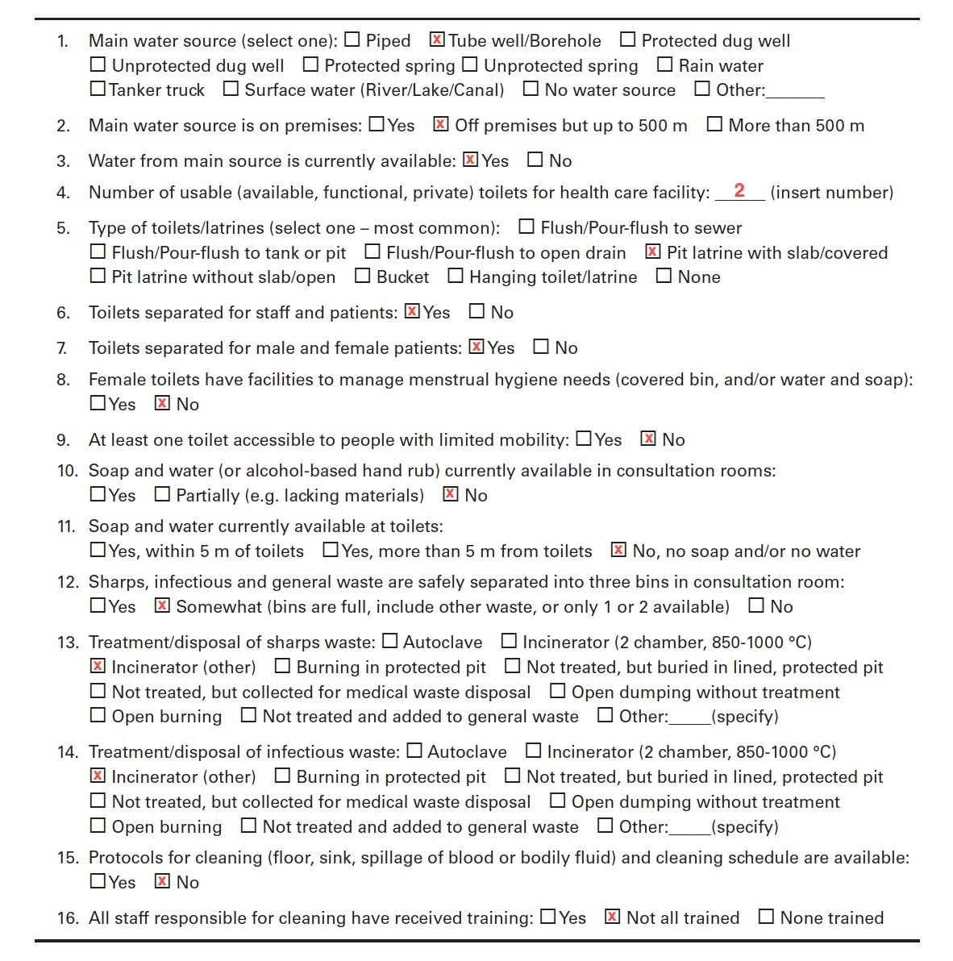
Source: Joint Monitoring Programme core questions and indicators for monitoring WASH in health care facilities in the Sustainable Development Goals

A2. JMP core questions for monitoring WASH in HCFs, Chipembele Health Post, Monze district
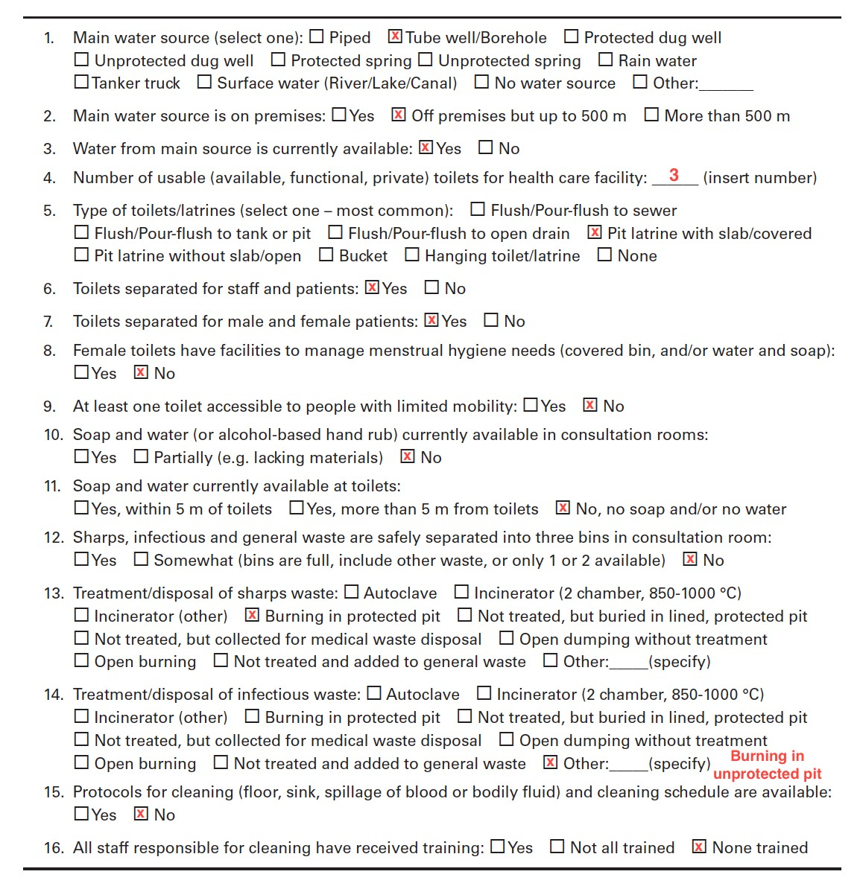

Source: Joint Monitoring Programme core questions and indicators for monitoring WASH in health care facilities in the Sustainable Development Goals

B1. Additional photographs from Njola Mwanza Clinic
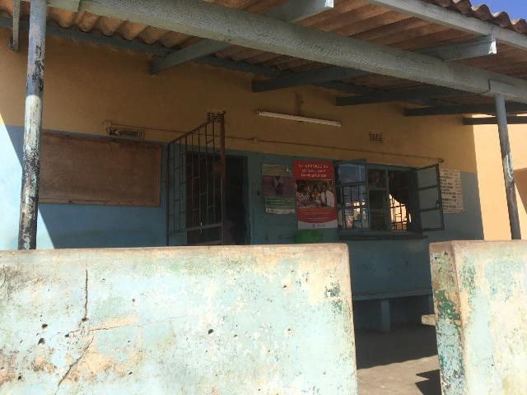
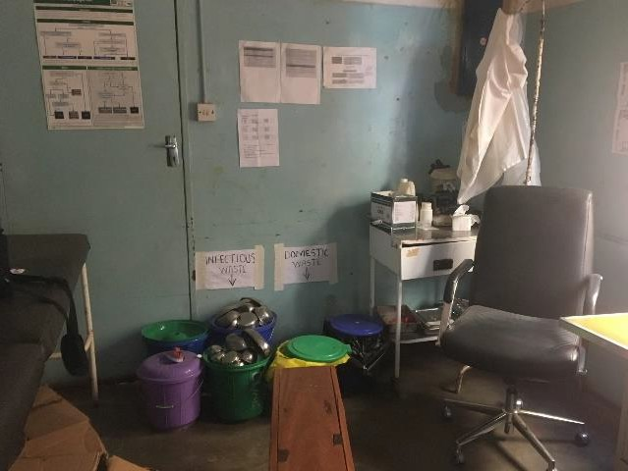

          - (b)
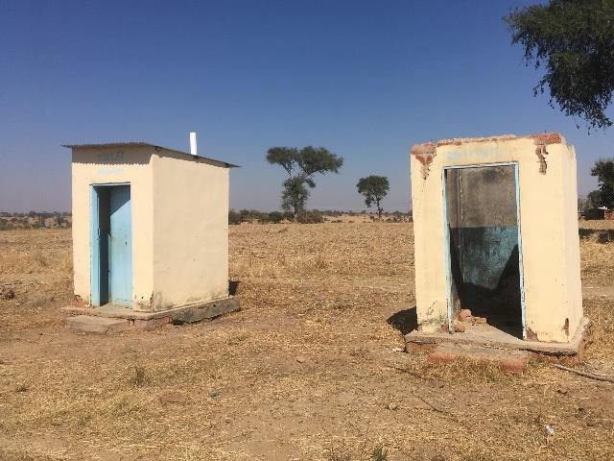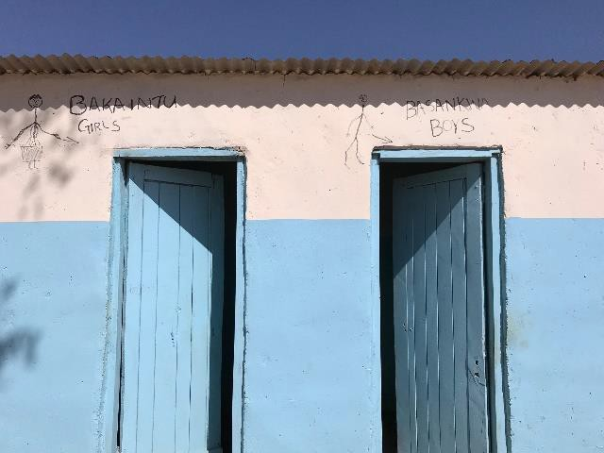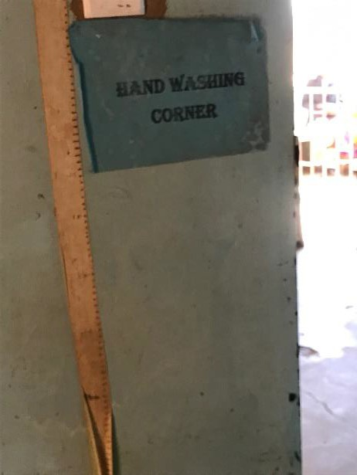
(e)

- Outside of the outpatient department
- Consultation room
- Used VIP latrines in the backyard
- Outside of the patient toilets
- Hand washing sign inside the consultation room
(c)
(d)

B2. Additional photographs from Chipembele Health Post

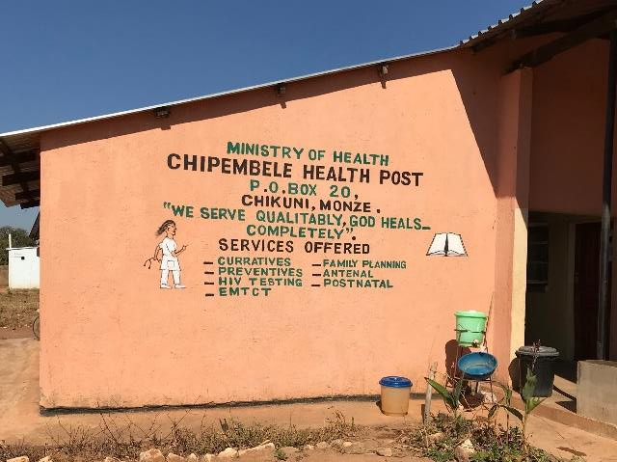  (a) | 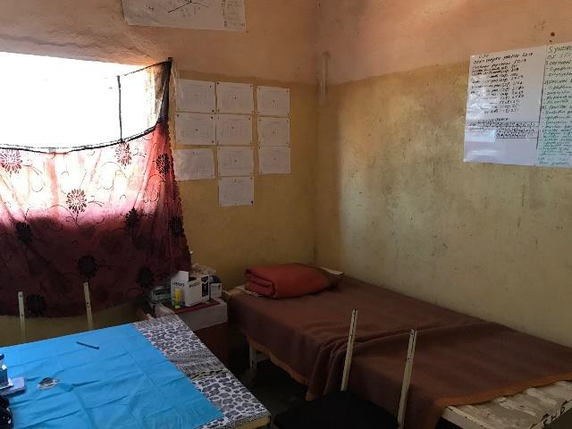  (b)
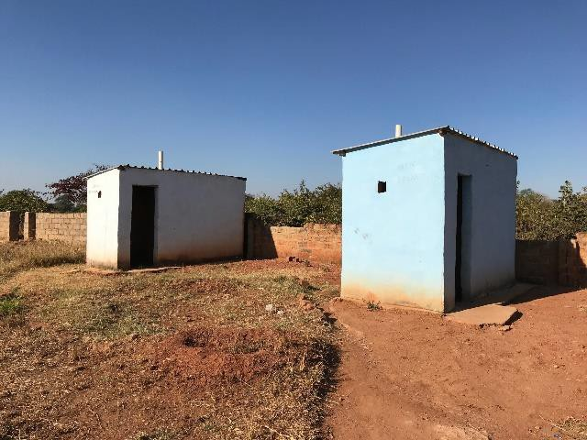  (c) | 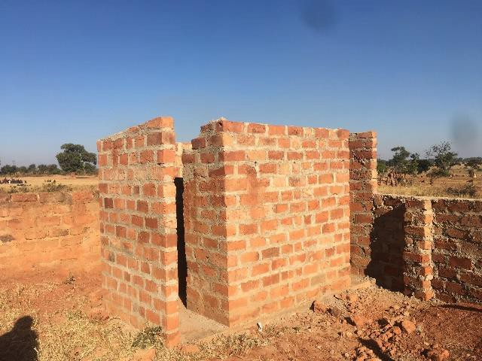  (d)
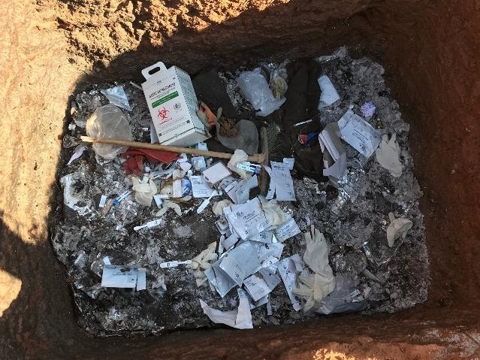  (e) | - Outside of the facility  - Consultation room  - Outside of the patient toilets  - Staff toilet  - Contents inside the incineration pit

C1. Table of Interview Notes

 |  | Opinions on Barriers to WASH in rural HCFs
Stake- holder | Standards | Funding Allocation | Hardware Maintenance | Community Members | Human Resource | Policy and Research
Lusaka Eye Hospital | _Even though the guidelines are sufficient and feasible, there is a lack of resources in HCFs to meet the guidelines.  _The HCFs do have the capacity to reach the minimum standards thus the government should provide the means for the HCFs to meet the guidelines. | _The MOH budget is already insufficient. | _There is lack of surveillance and maintenance of government-built facilities. | _Lack of community involvement: rural community members have low motivation to improve WASH
UNICEF | _Efforts have been made to ensure that minimum standards are aligned with WHO/UNICEF (JMP)  expectations  _Guidelines are attainable in rural context. Enforcement is the responsibility of the MOH | _Financial support is needed to keep the existing resources functioning over time | _Operation and maintenance of infrastructure  _Supporting systems not as good as systems themselves (i.e. availability of spare parts and local expertise for repairs) |  | _Lack of capacity of human resources | _Some enforcement elements will be contained as a part of the Public Health Act, which is currently under review.

C2. Table of Interview Notes (continued)

 |  | Opinions on Barriers to WASH in rural HCFs
Stake- holder | Standards | Funding Allocation | Hardware Maintenance | Community Members | Human Resource | Policy and Research
Chipem- bele Health Post | _Has not shown any standards on WASH |  | _No incinerator.  _Financial resources would be used to buy motorbikes for outreach and antenatal care, build maternity annex and staff housing.  _Is in need of other resources such as soap and running water.  _There is a need of visual aids to educate and induce behavior change | _Lack of community members’ awareness of the importance of hand hygiene in preventing diarrhea  _Even though the staff instructs to boil water when chlorine is unavailable, compliance may be low | _Aware that the standards do exist, but he has not shown them  _Insufficient staffing: staff are sometimes too busy to wash hands
Njola Mwanza Clinic | _The standards are appropriate and can be reached with resources such as up-to- standard incinerators and other hardware support. | _Insufficient funding from the government | _Maintenance of existing facility: iron pipes are hard to maintain; the recent installation of PVC pipes has helped. | _Poverty raises a barrier to community participation, because community members are unwilling to provide money to improve the facility | _Handwashing by staff is not frequent due to a heavy workload  _Aware that standards do exist, but did not know the source of them.  _Insufficient staffing: sometimes staff are too busy to wash hands

C3. Table of Interview Notes (continued)

 |  | Opinions on Barriers to WASH in rural HCFs
Stake- holder | Standards | Funding Allocation | Hardware Maintenance | Community Members | Human Resource | Policy and Research
An  American non-profit organization | _Believes the national standards are in line with the JMP guidelines.  _Enforcement may happen in urban facilities but may not in rural facilities. It is in need of MOH’s support to meet the standards. | _There hasn’t been a straightforward policy on improving WASH in rural HCFs due to the urban focus of funding.  _Other health issues compete for limited funding, and building and maintaining WASH infrastructure is costly. |  |  | _There is a lack of staff that is knowledgeable of WASH principles and capable of practicing, teaching and building up of knowledge.  _The capacity of health committees in the HCF is limited. | _There hasn’t been much detection for WASH-related diseases in rural communities because the main focus has been on urban/peri-urban. The specificity of disease report needs to improve  _Policy: WASH is often times not a priority in the agenda of HCFs, where they have competing priorities for other health problems  _A disconnection (communication of needs and actions) between the ministries that should work together towards improving WASH  _There is little information and little public health surveillance to verify hospital-acquired infections in a rural setting.

C4. Table of Interview Notes (continued)

 |  | Opinions on Barriers to WASH in rural HCFs
Stake- holder | Standards | Funding Allocation | Hardware Maintenance | Community Members | Human Resource | Policy and Research
Ministry of Health | _The current minimum standards are inadequate and do not align with the JMP standards.  Believes it requires more details and comprehensiveness  _The standards are attainable in a rural context, yet there is an issue of prioritization. | _Funding distribution: WASH is deprioritized in receiving already insufficient funding (most funding is external, not from the government)  _Allocation of budget is population-based thus is focused more on the urban areas  _Global focus on curative intervention on HIV/AIDS, TB, and  malaria: little attention is given to environmental safeguards to these interventions that receive the most funding. | _The lack of proximal handwashing facilities for staff may lead to inconsistent handwashing.  _Lack of adequate chemicals to clean the clinic environment | _Lack of awareness on the importance of occupational risk and public health hazard associated with poor WASH | _Lack of logistics/training for IPC  _Human resources: health-related workers prefer to be in cities due to an ease of living. | _The ministry uses performance assessments as a way to monitor whether the standards are followed.  _The ministry is currently planning to integrate WASH into the revision of the Public Health Act to legalize and enforce the WASH elements.  _Priority setting: the government should prioritize WASH in HCFs at the planning level

